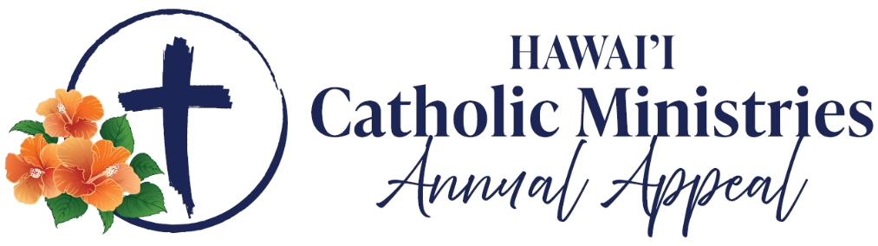

Announcement Weekend: February 14-15
Talking Points for Pastors

The following talking points are provided to assist you with introducing the Catholic Ministries Annual Appeal (CMAA) as the new annual appeal that continues and strengthens the mission formerly supported through the ’Ohana in Christ appeal.

  - This year, our Church in Hawai’i is launching the Catholic Ministries Annual Appeal (CMAA), which replaces the ’Ohana in Christ appeal. While the name is new, the mission remains the same — to come together as one Catholic community in support of the ministries and programs that serve our islands.

  - The CMAA invites Catholics across Hawai’i to renew our shared commitment to care for one another, nurture faith at every stage of life, and serve those most in need.

  - Next week, and in the coming weeks, I will ask each of you to generously support the CMAA, knowing that every gift helps strengthen our Catholic community and carry forward Christ’s mission throughout the islands.

  - Your support of the CMAA helps fund essential ministries such as faith formation for children, youth, and adults; the formation and care of our priests, deacons, and seminarians; and pastoral and social ministries that provide hope, dignity, and compassion to those in need.

  - Some of you may have already received a letter from Bishop Larry introducing the Catholic Ministries Annual Appeal. I encourage you to read it carefully and prayerfully reflect on how your generosity can help further the work of our Church.

  - Finally, regardless of your ability to make a financial gift, I ask you to keep the success of the Catholic Ministries Annual Appeal — and all those it serves — in your prayers.

